**Artificial Intelligence Lab**

Developing Agent Programs for Real World Problems

Graph Colouring Problem

**Name** - N Aditya Sai

**Register Number**- RA1911030010075

**Experiment** – 2

**Code:** (Vertex Colouring)

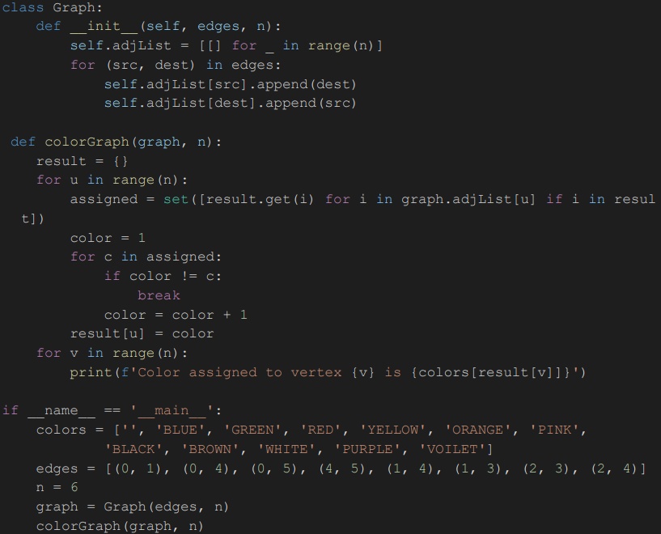

**Graph before Vertex Colouring:**

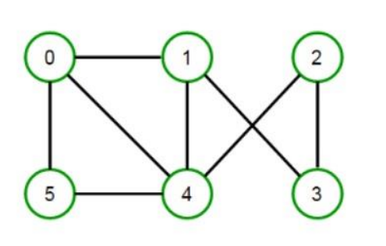

**Output Screenshot:**

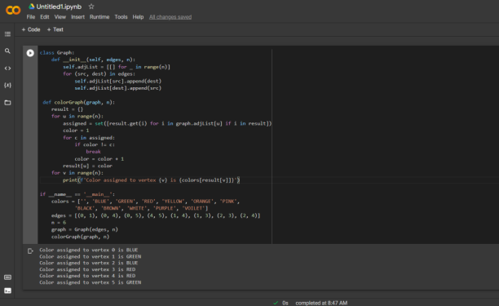

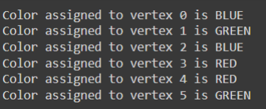

**Graph after Vertex Colouring:**

